
MATHEMATICS METHODS Unit 1
2022 Investigation 1
Take Home Section

NAME: ______________________________
Validation Test: Monday 9th May 2022
Weighting: 8%

Transformations of Functions

INSTRUCTIONS:
  - It is recommended you work in small groups after school hours and come to tutoring.
  - The Take Home part is not worth any marks.
  - The Take Home part may be used in the validation test.
  - You are encouraged to use your ClassPad to help you to complete the Take Home part.
  - No calculators will be allowed in the validation test.

Introduction:
A function is an equation for which any x that can be plugged into the equation will yield exactly one y out of the equation. We can draw a graph of a function on the Cartesian plane.
TRANSFORMATIONS include:
- Translations: (horizontal or vertical)
- Dilations: (horizontal or vertical)
- Reflections: (horizontal or vertical)
There are certain actions we can perform on a function that change the graph in specific ways. These are called TRANSFORMATIONS.

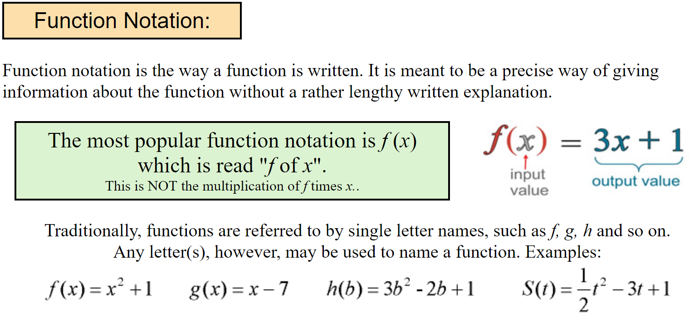

- The function is graphed below.
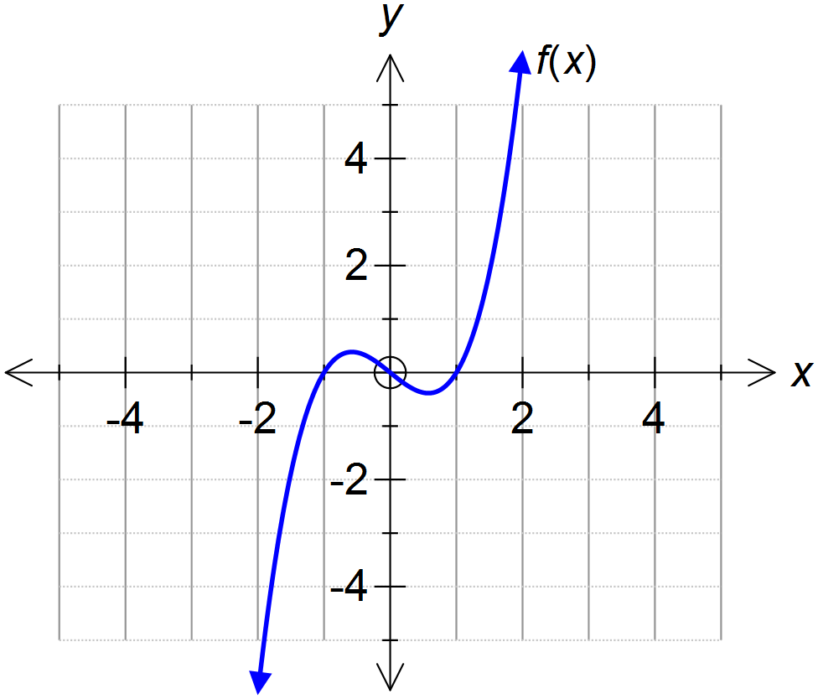

Use your Classpad to investigate how each of the following changes to affects the graph. Make sure you consider both positive and negative numbers. It is recommended that you draw your results on graph paper.

- Adding a number (constant) to the function. Eg. Adding 2 to the function results in.

- Adding a number to the variable. Eg. Adding the number 2 to the $x$ value in the function
so that every $x$ in the function has been replaced by $(x+2)$. This results in the transformed function:
.

- Multiplying the function by a constant Eg. If the function is multiplied by 2, $f(x)$ transforms to $2f(x)$. Thus using our transformed function becomes $2f\left(x\right)=2x^{3}-2x$.

- Multiplying the variable by a number. Eg Multiplying the variable by 2 using our transformed function becomes $f\left(2x\right)=(2{x)}^{3}-2x$ which simplifies to $8x^{3}-2x$. Consider also multiplying the variable by a fraction <1 Eg. Multiplying the variable by $\frac{1}{2}$ using our transformed function becomes $f\left(\frac{x}{2}\right)=({\frac{x}{2})}^{3}-\frac{x}{2}$ which simplifies to $\frac{x^{3}}{8}-\frac{x}{2}$.

- Investigate the transformation from Q1 above with other graphs such as:

- $f\left(x\right)=\sqrt{x}$
- $f\left(x\right)=\frac{1}{x}$ or $f\left(x\right)=x^{-1}$
- $f\left(x\right)=x^{2}$
PRACTICE PROBLEMS 1

- Drawn to the right is the graph of $f\left(x\right)=x^{4}-3x^{2}+x$
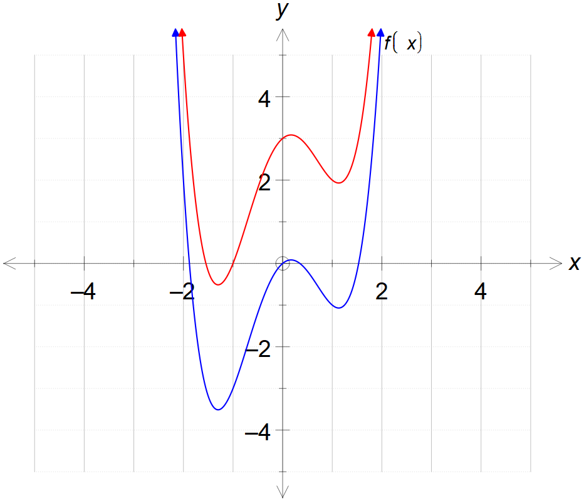
- Using the terminology for transformations from page 1, describe the transformation on f(x)
if the equation becomes
.

- Add the sketch of to
the same set of axes.

- 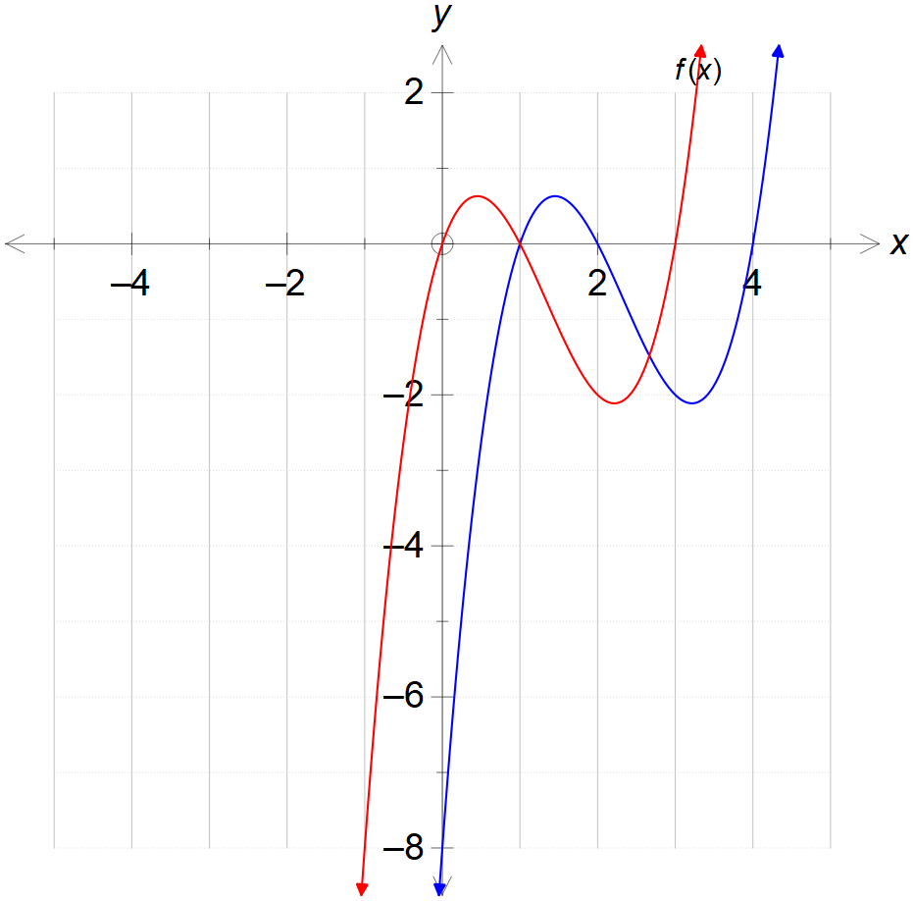Drawn to the right is the graph of $f\left(x\right)=x^{3}-7x^{2}+14x-8$

- Write down the new equation for $f(x+1)$

- Add the sketch of $f(x+1)$ to
the same set of axes.

- Fully describe the transformation.

PRACTICE PROBLEMS 2

Draw each transformation on the original axes shown.

$f(x)→f(x+4)$ $f\left(x\right)→f\left(x\right)+1$

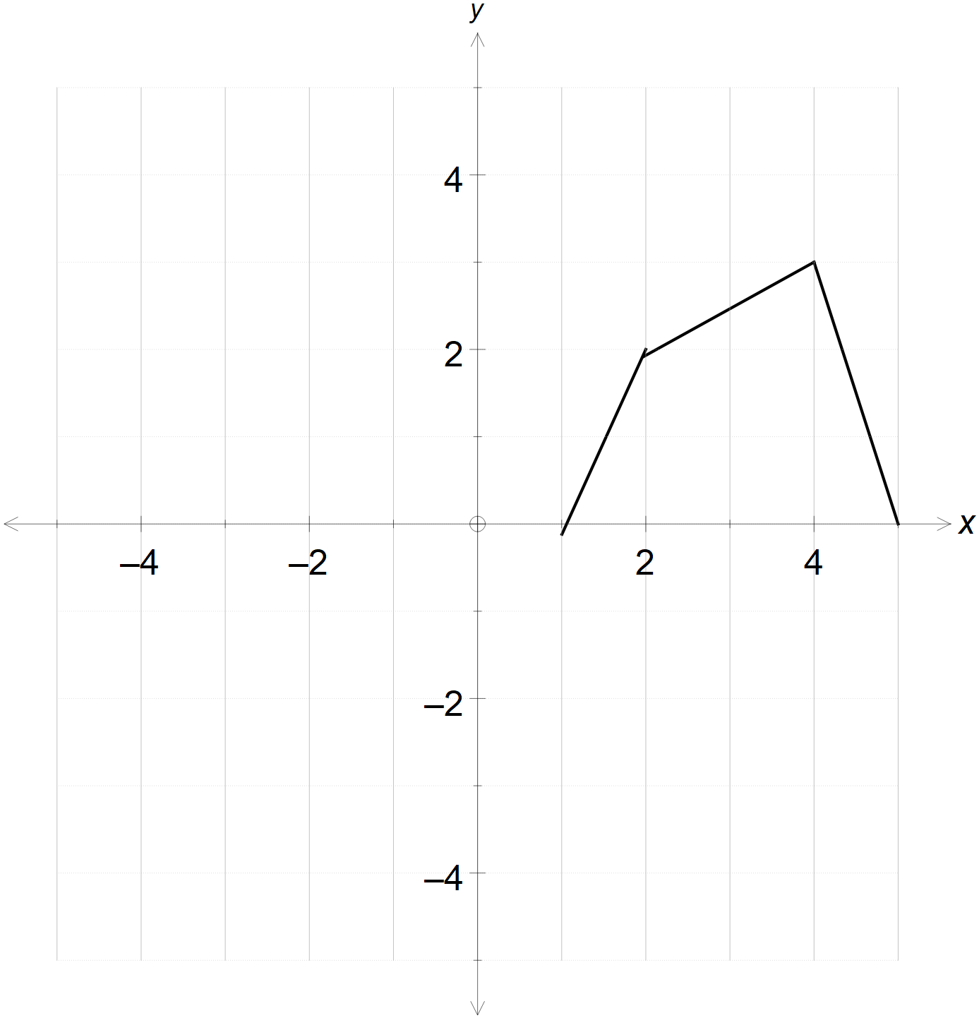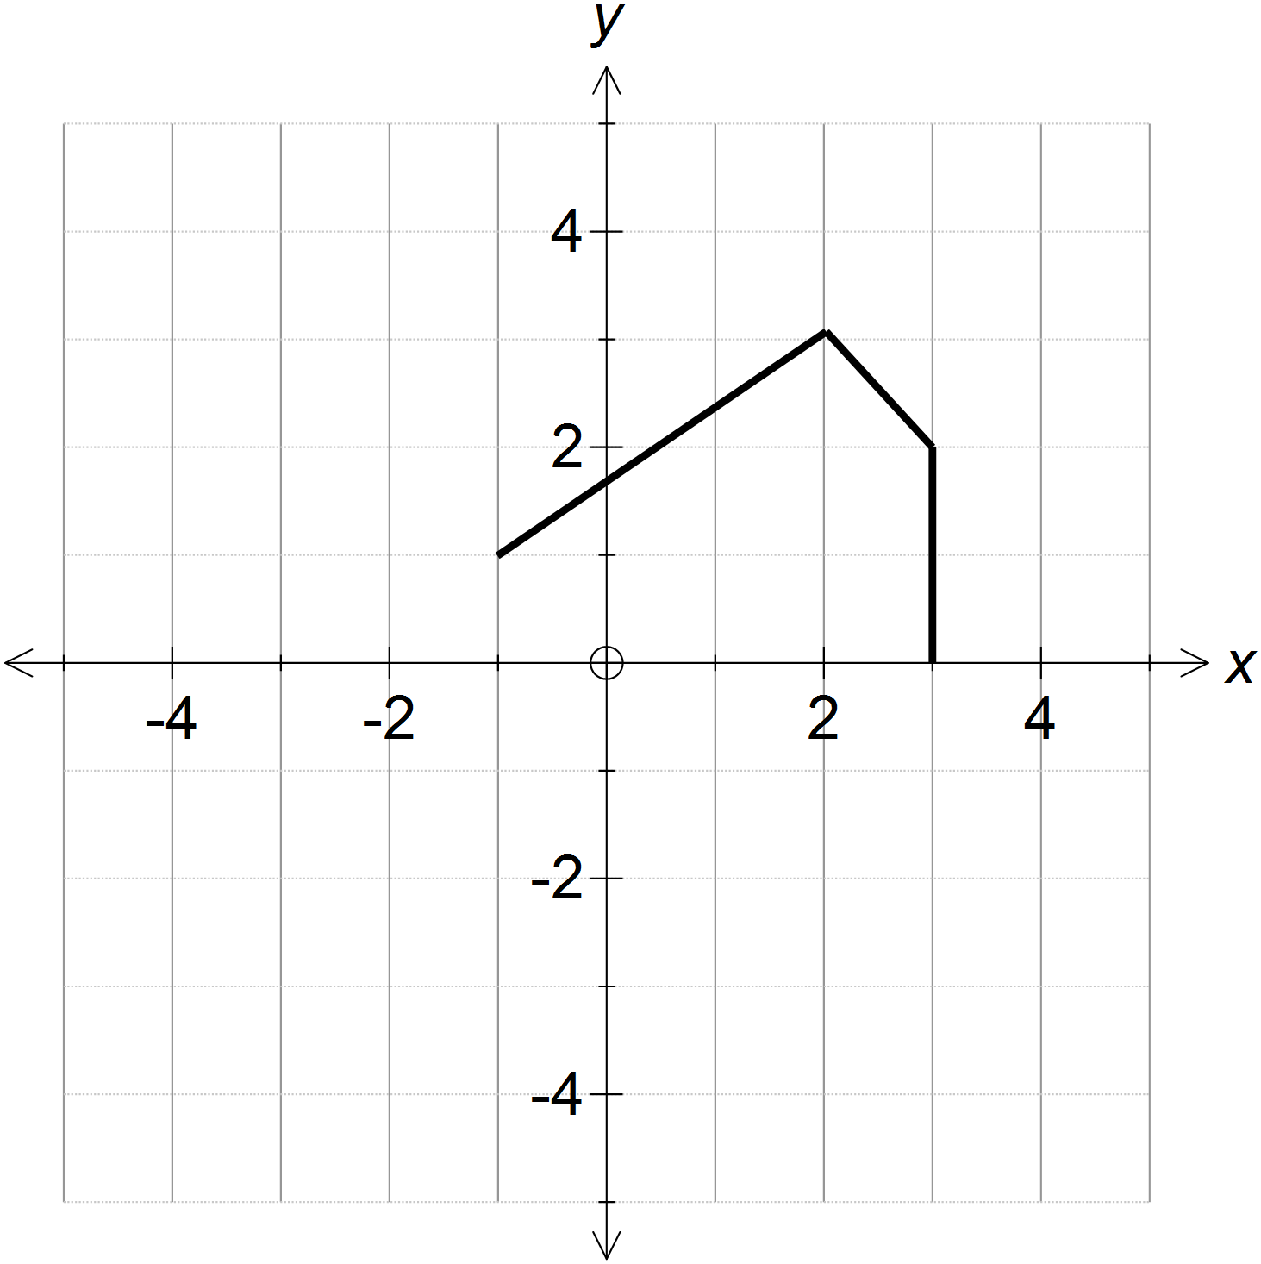

$f\left(x\right)→f\left(x-2\right)$ $f\left(x\right)→f\left(x-1\right)-4$

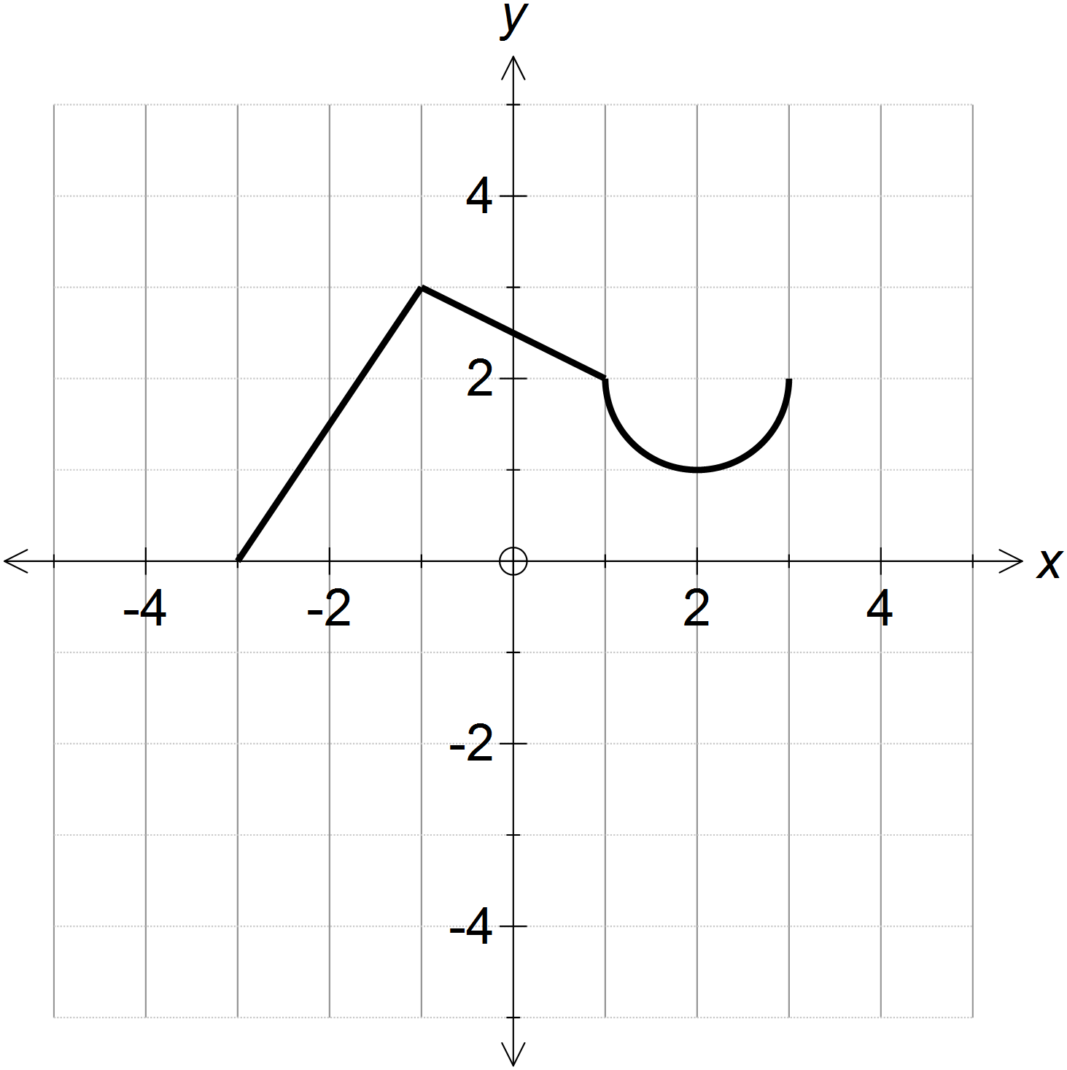

PRACTICE PROBLEMS 3

Draw each transformation on the original axes shown.

$f(x)→f(2x)$ $f\left(x\right)→f\left(\frac{1}{3}x\right)$

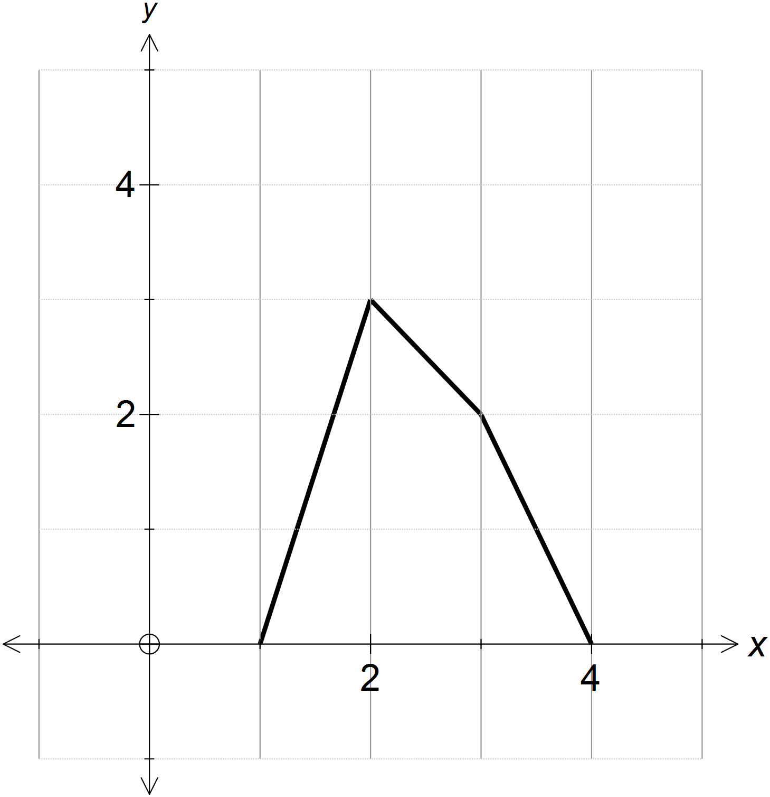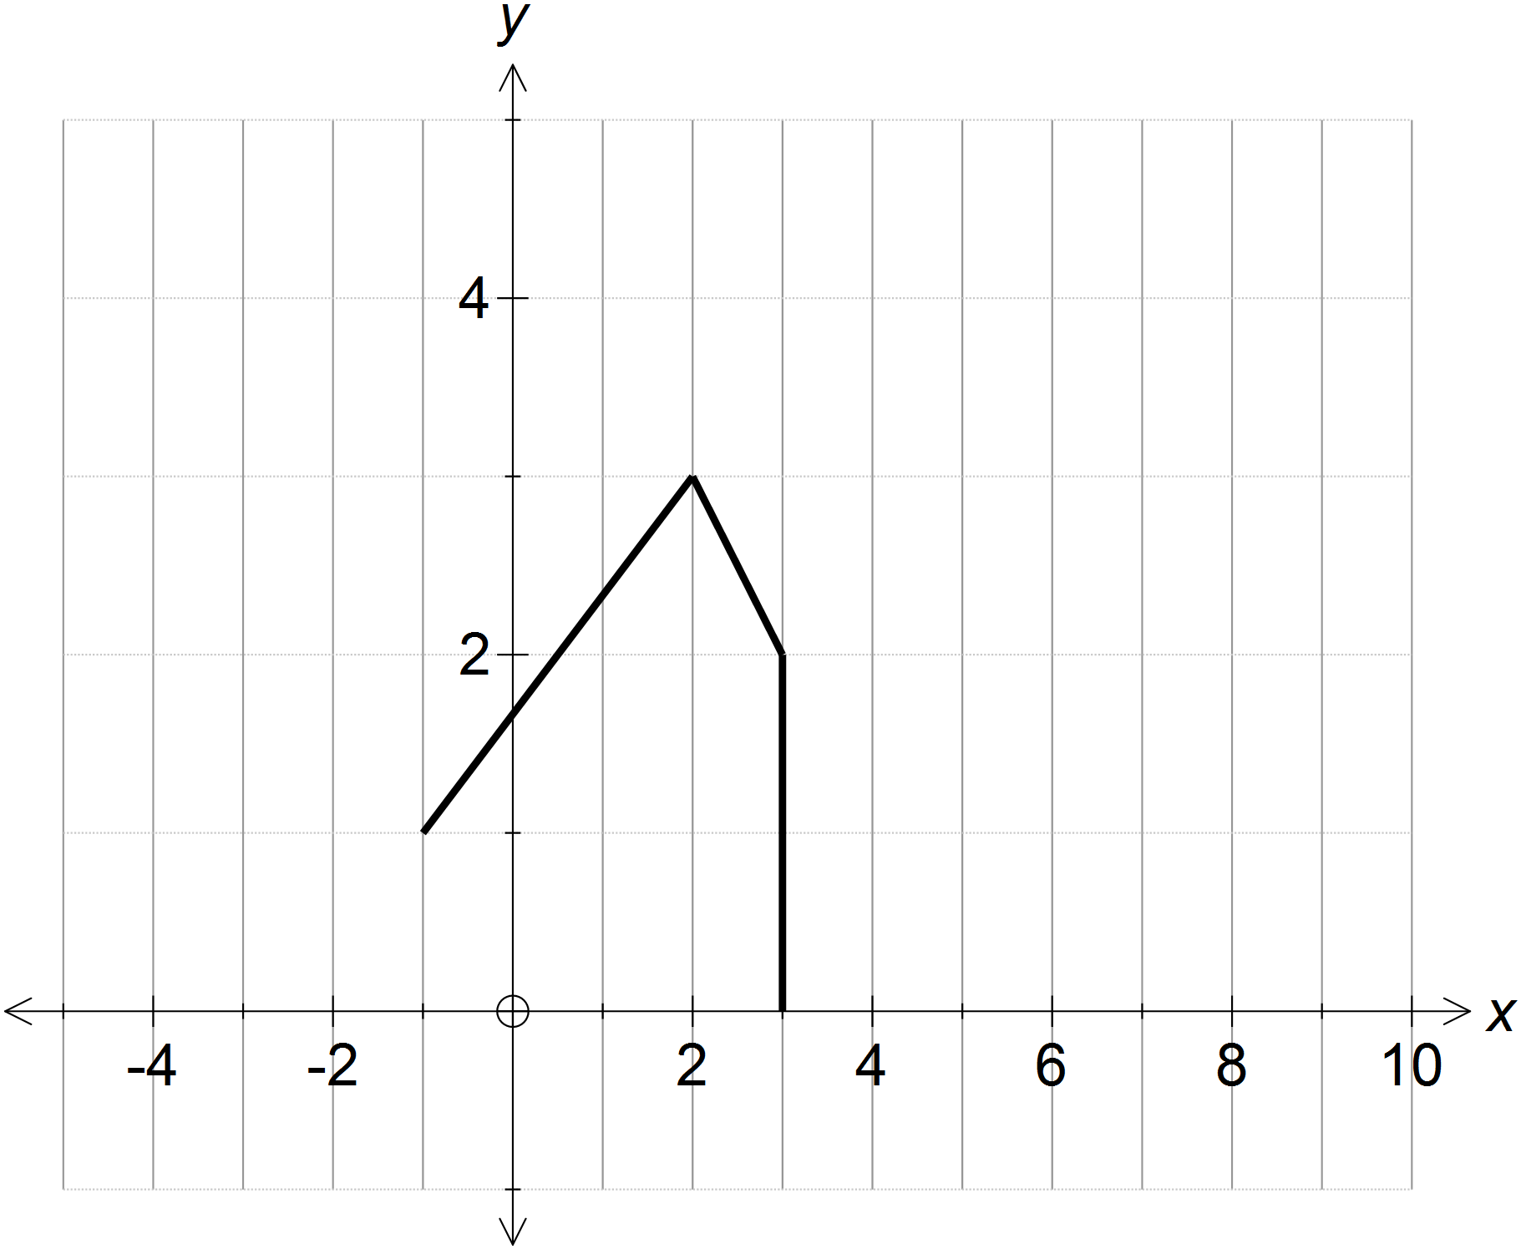

$f\left(x\right)→2f\left(x\right)$ $f\left(x\right)→\frac{1}{2}f\left(x\right)$

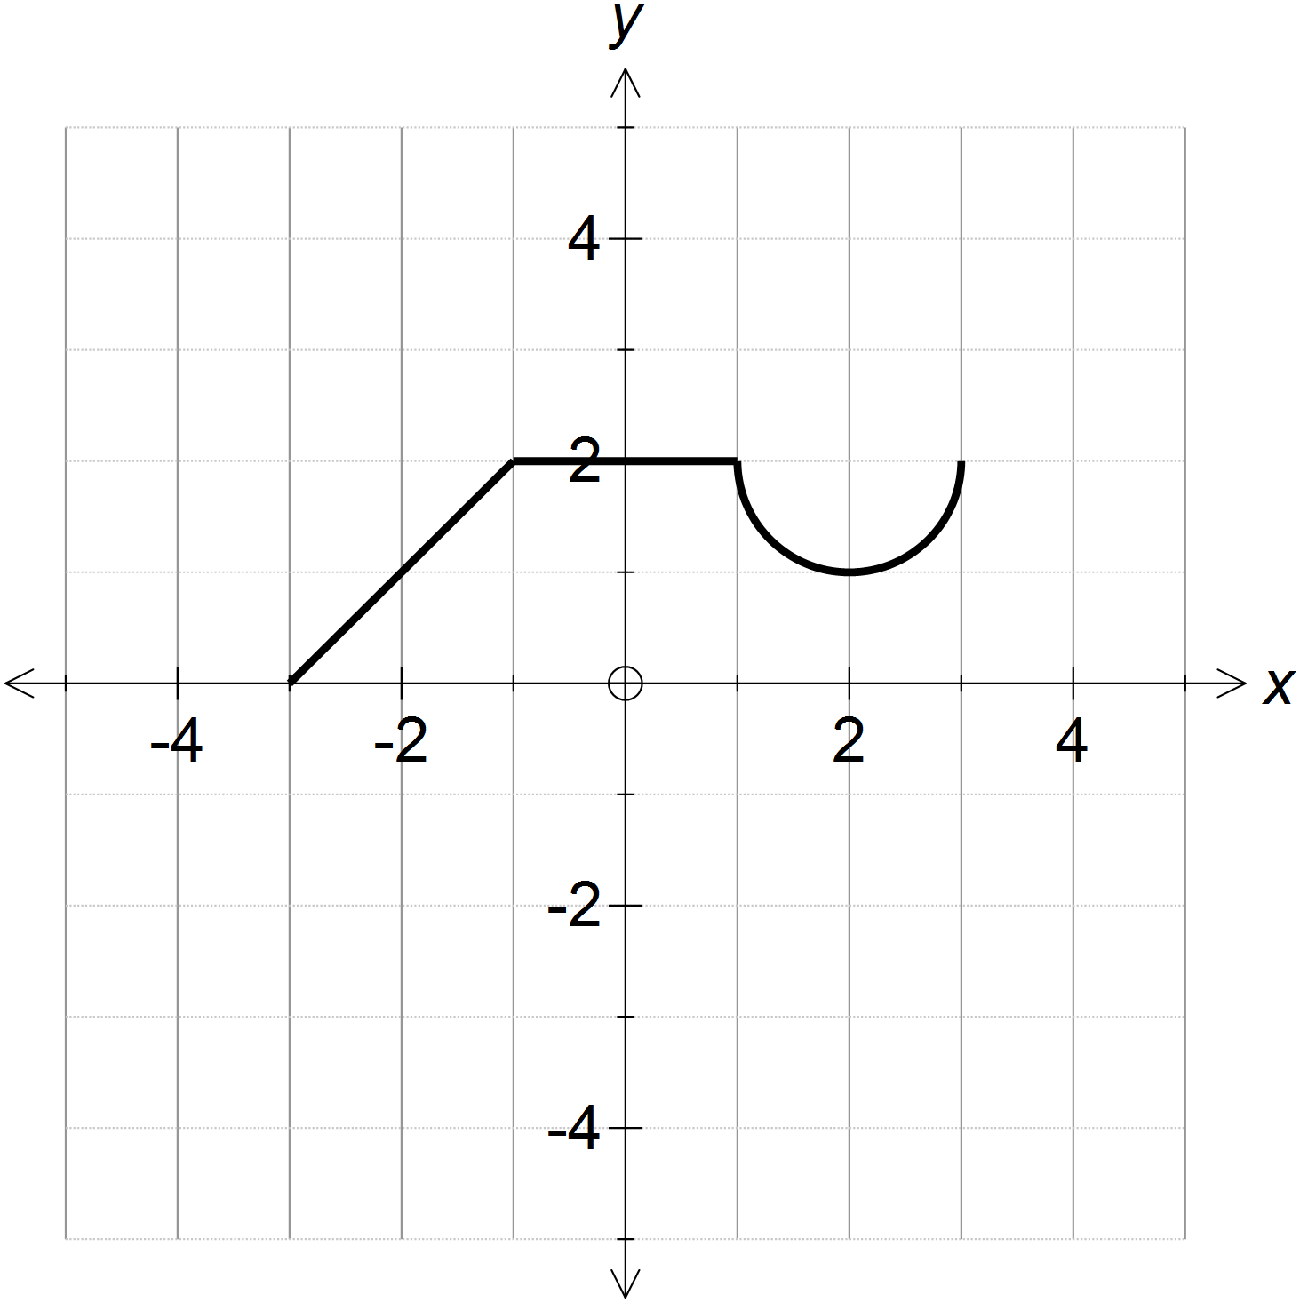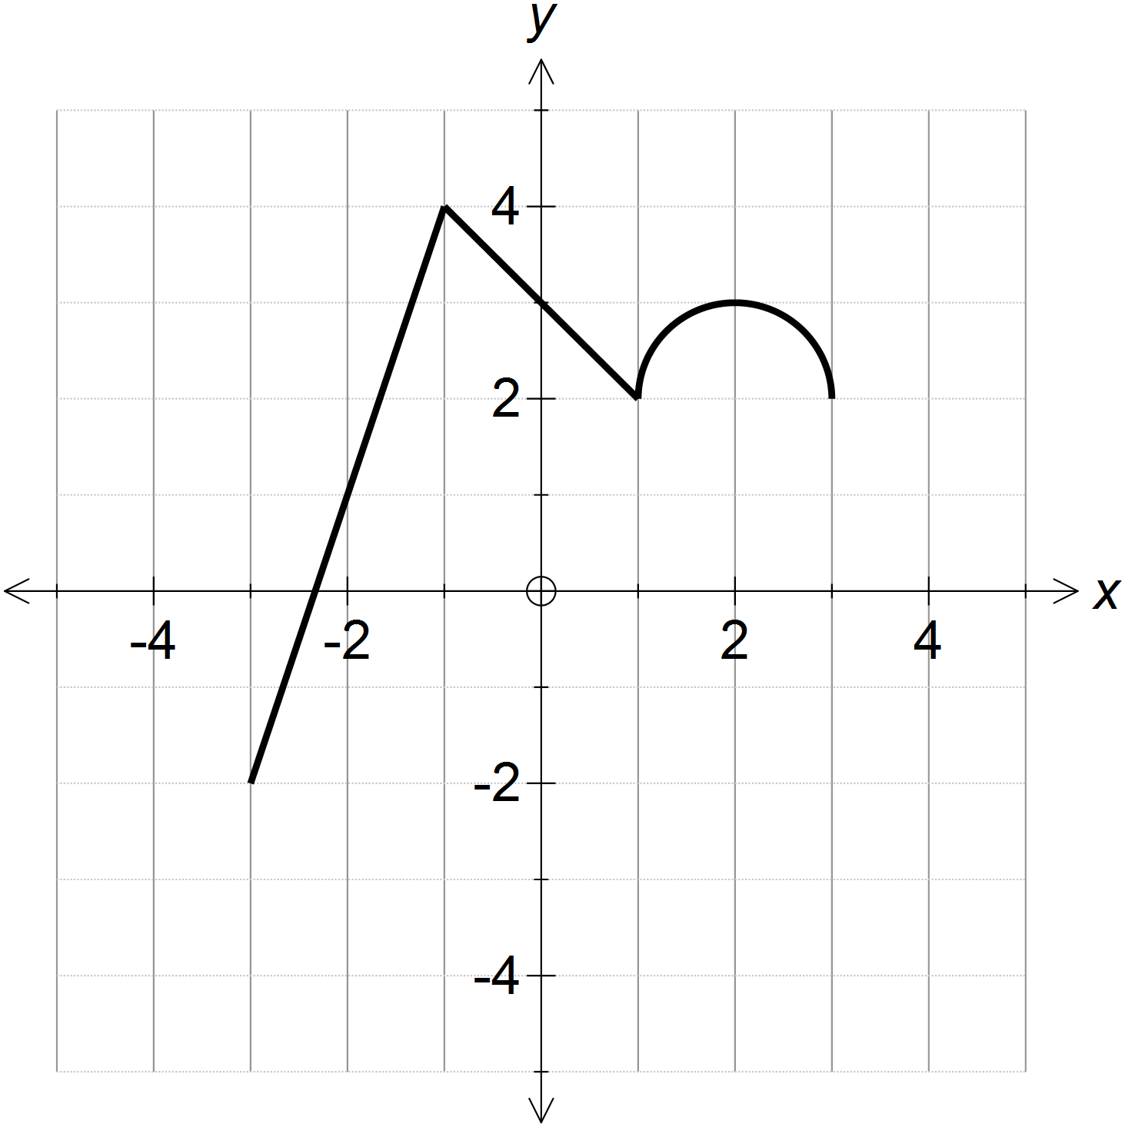

PRACTICE PROBLEMS 4
For each of the following:
- Use your classpad or otherwise to draw each of these original functions.
- Write down the new equation according to the transformation shown.
- Sketch the graph of both the original function and the transformation on the axes provided.

$f\left(x\right)=(x-1)(x-2)(x-4)$ with transformation $f(x)→2f\left(x\right)$.  $$2f\left(x\right)=2(x-1)(x-2)(x-4)$$  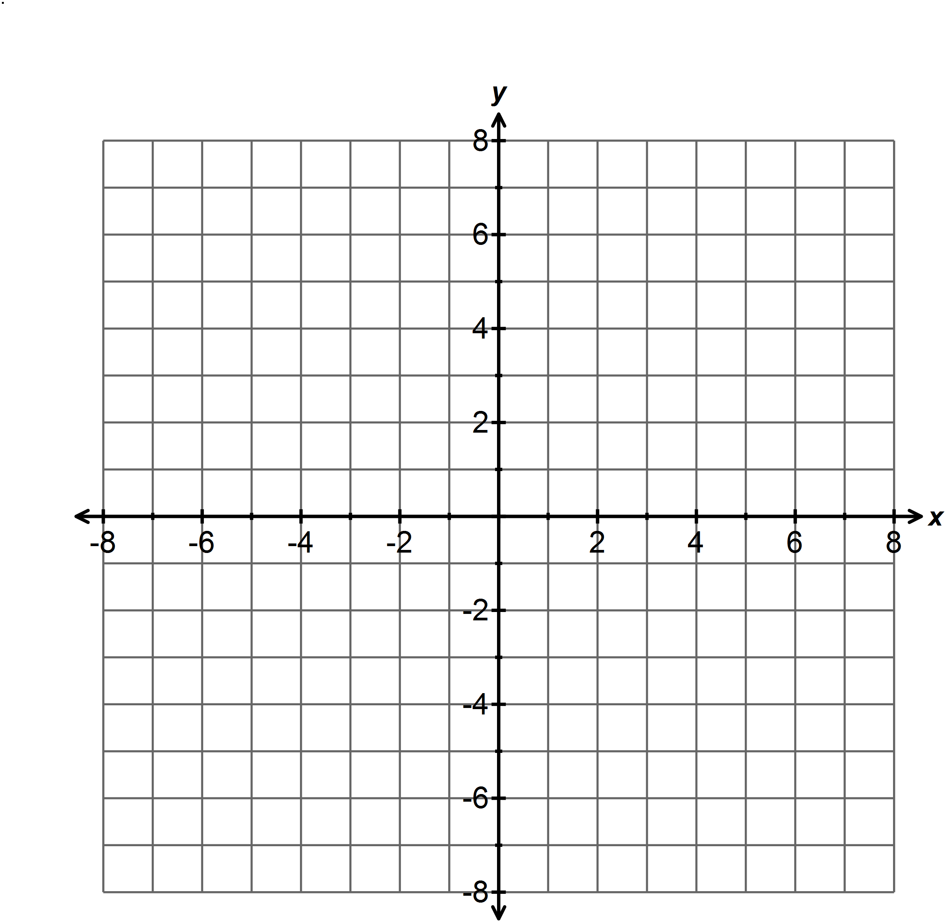 | $f\left(x\right)=x^{3}-3x$ with transformation  $f\left(x\right)→-f(x)$.  $-f\left(x\right)=$ $-x^{3}+3x$  
$f\left(x\right)=\frac{1}{x-3}$ with transformation  $$f\left(x\right)→f\left(x\right)+2$$  $f\left(x\right)+2=$ $\frac{1}{x-3}+2$  | $f\left(x\right)=\sqrt{x-4 }$ with transformation  $$f(x)→f(x+2)$$  $f\left(x+2\right)=$ $\sqrt{x-2 }$  
$f\left(x\right)=\left(x+1\right)\left(x+2\right)\left(x-1\right)$ with transformation $f\left(x\right)→f\left(x-1\right)$  $$f\left(x-1\right)=x(x+1)(x-2)$$   | $f\left(x\right)={\left(x+1\right)}^{2}(x+2)(x-1)$ with transformation $f(x)→f(-x)$  $$f\left(-x\right)=(-x+1)(-x+2)(-x-1)$$  

Sketch the graphs of the following transformations:

$f\left(x\right)→2f\left(x\right)$ $f\left(x\right)→f\left(-x\right)$

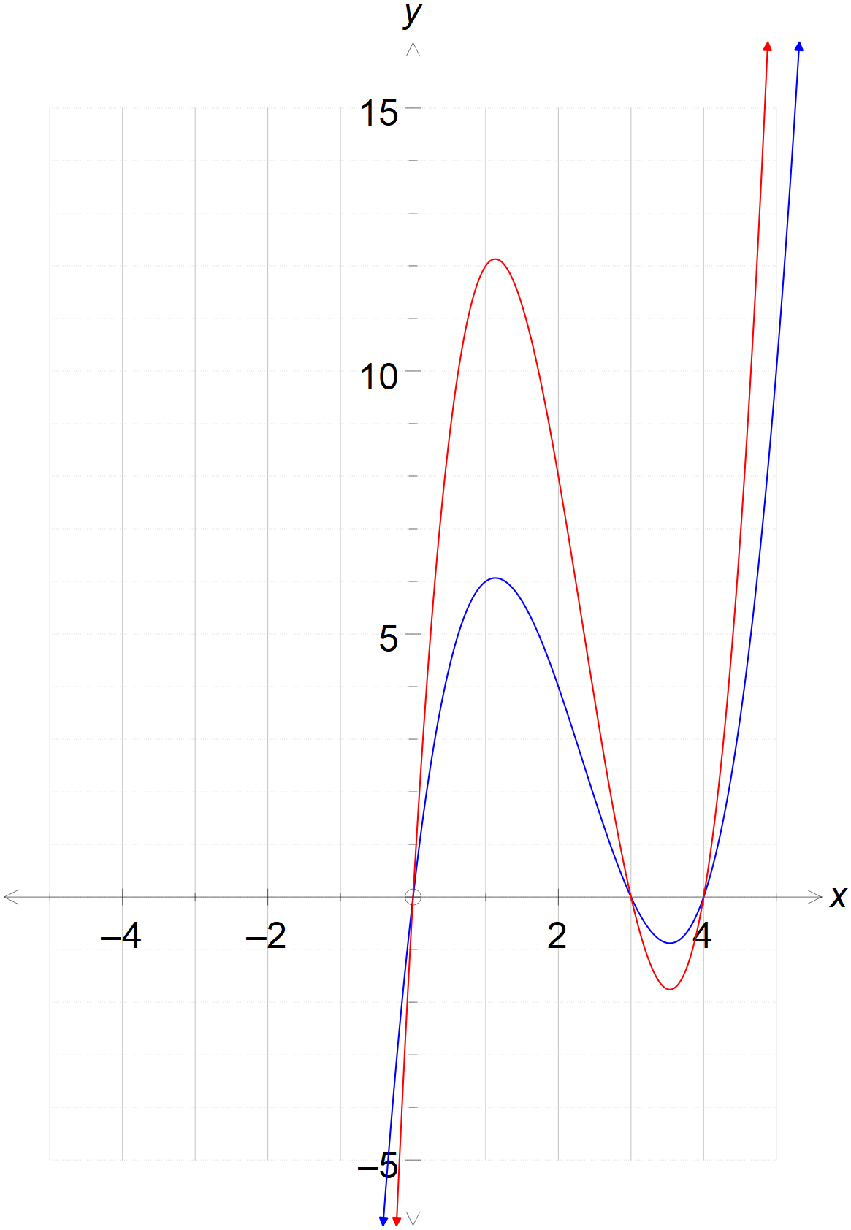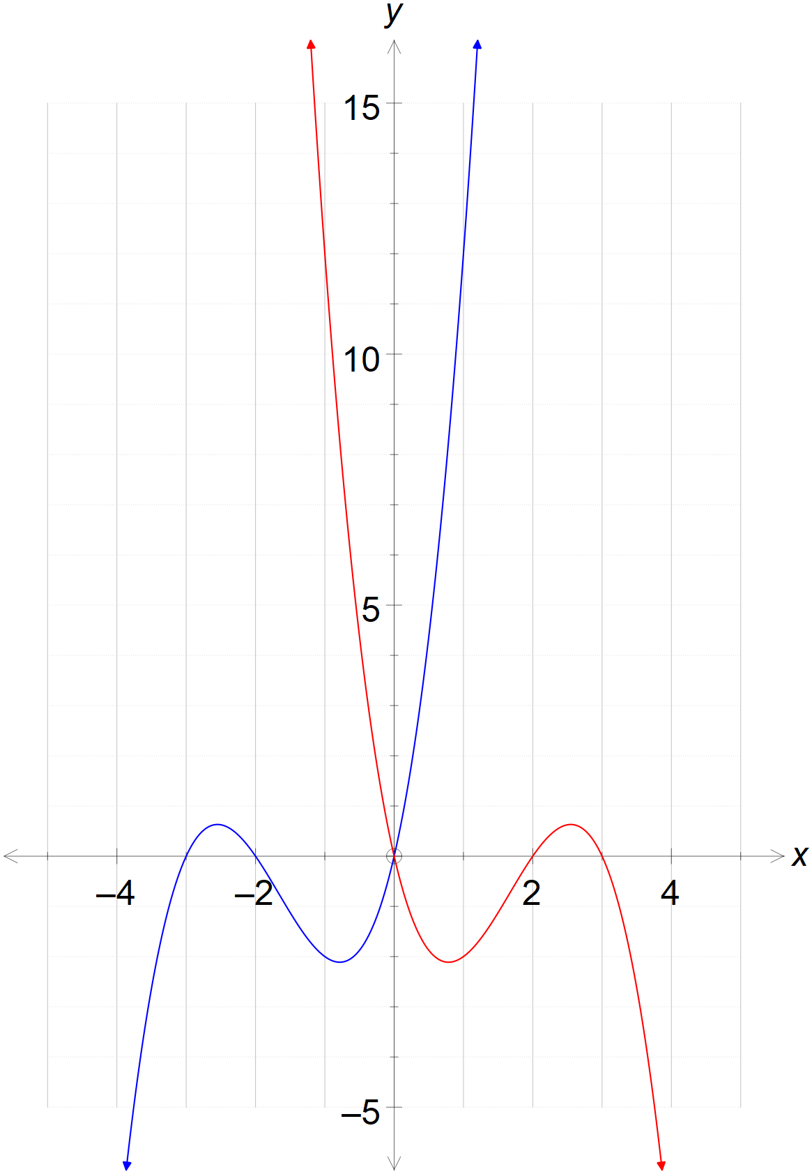
$f\left(x\right)→f\left(x+3\right)$ $f\left(x\right)→f\left(x\right)+3$

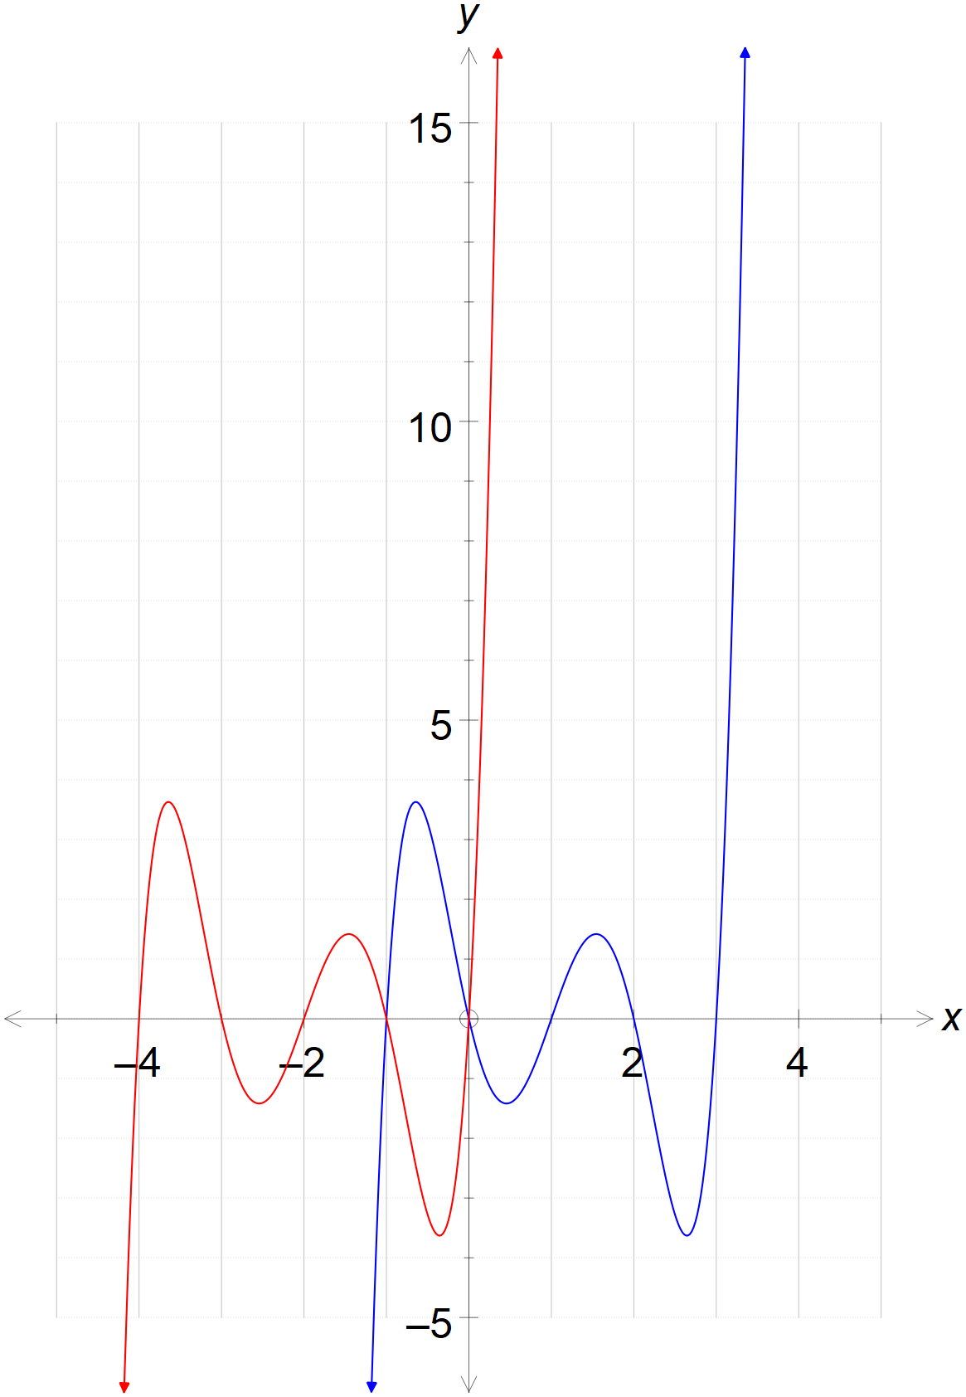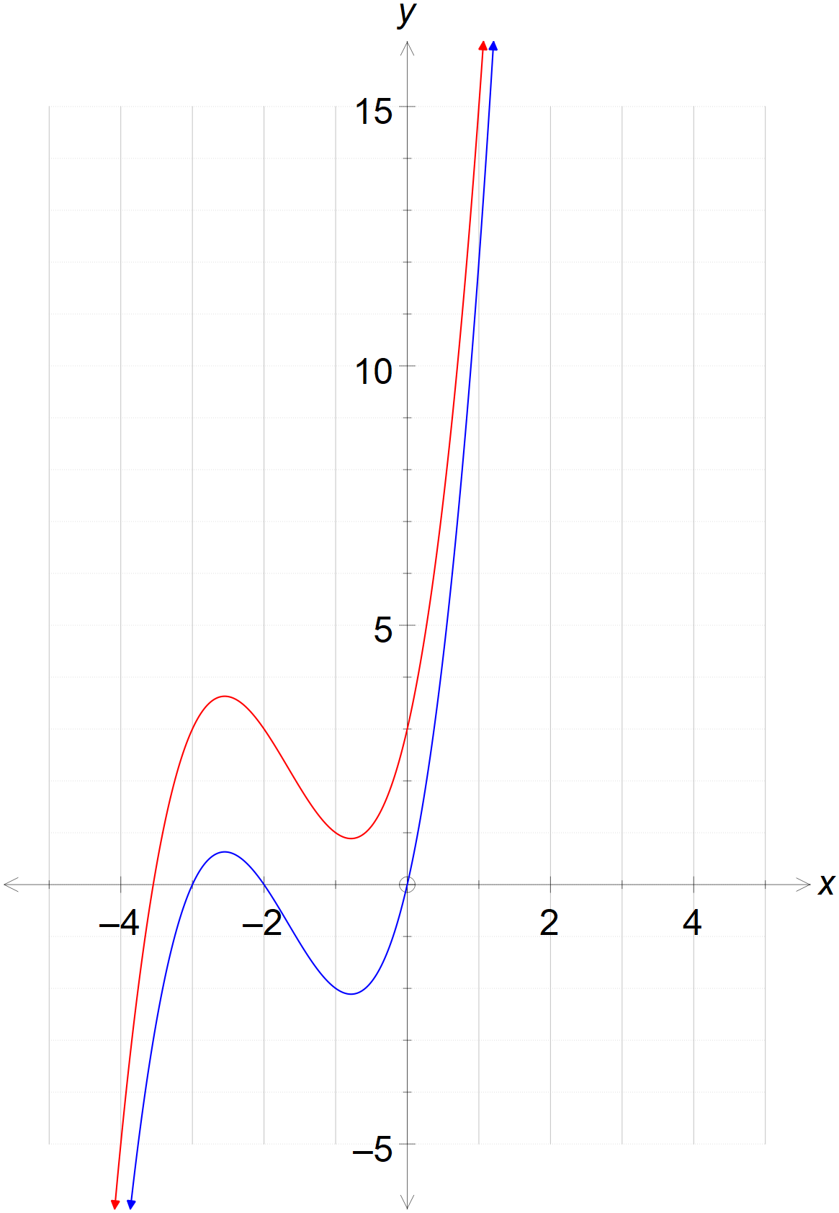

For each of the following, describe the transformation in words AND using function notation
(e.g. $f\left(x\right)→2f(x)$ or $f(x)→f(x-3)$ )
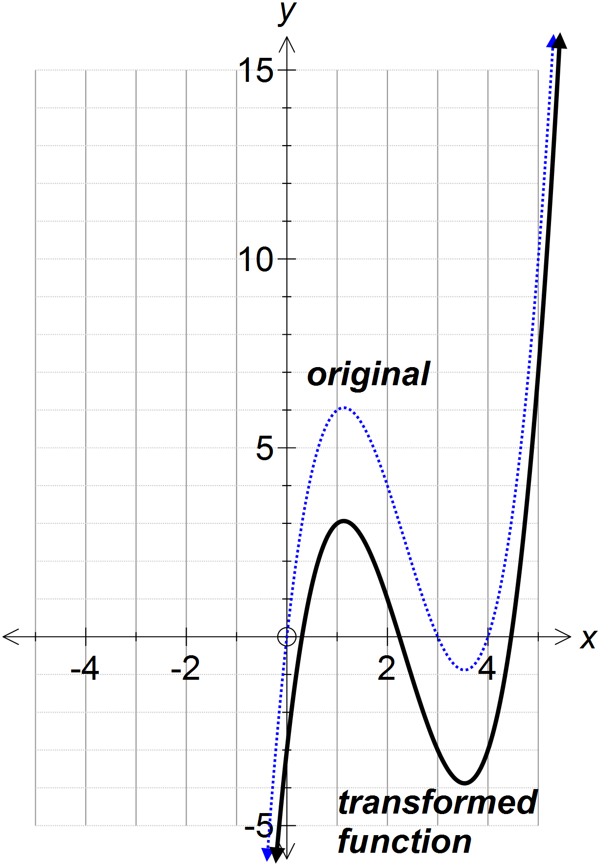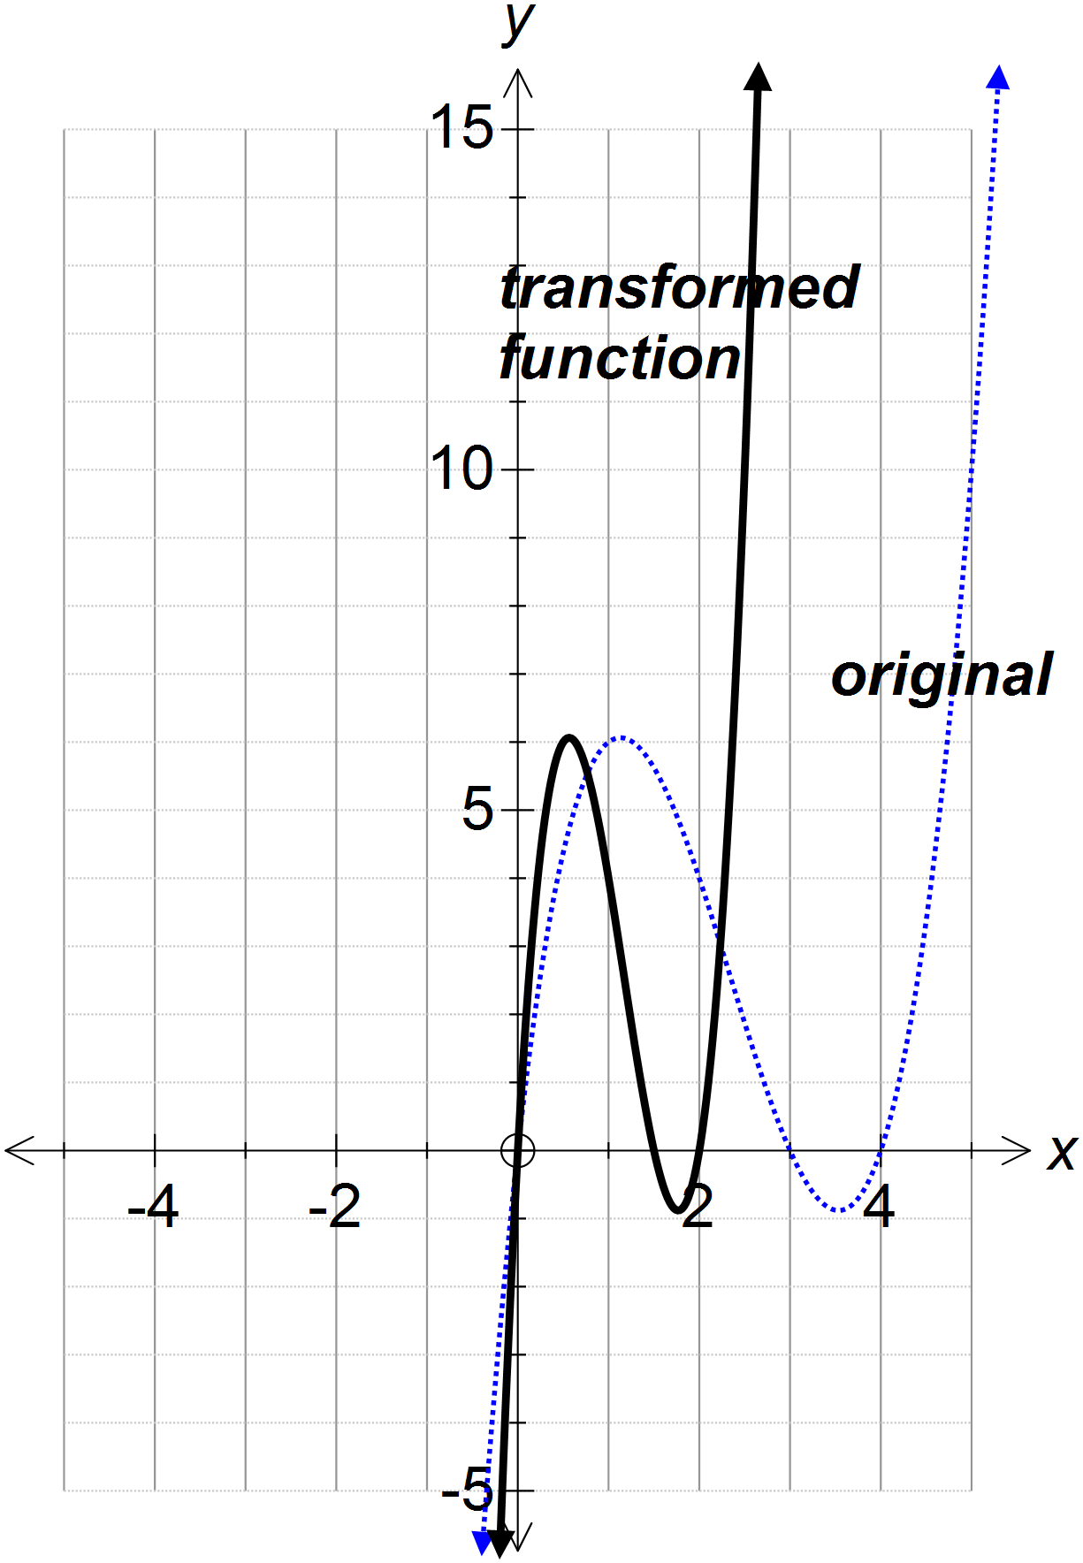

$f(x)→$ ________________________ $f(x)→$ ________________________
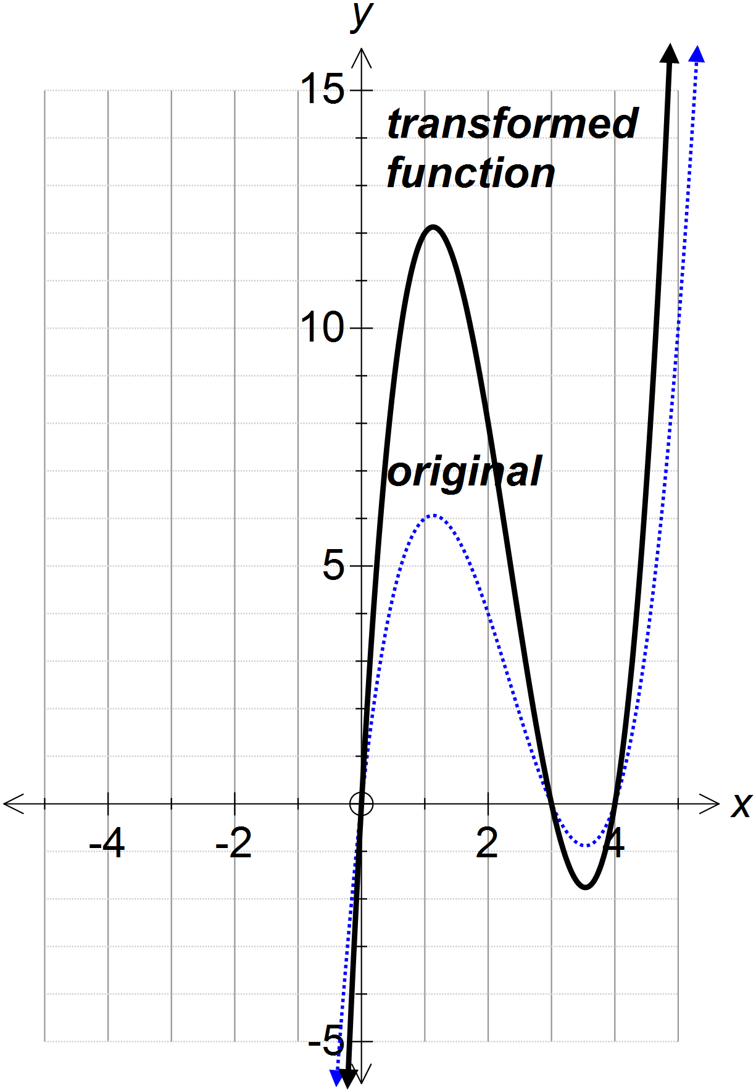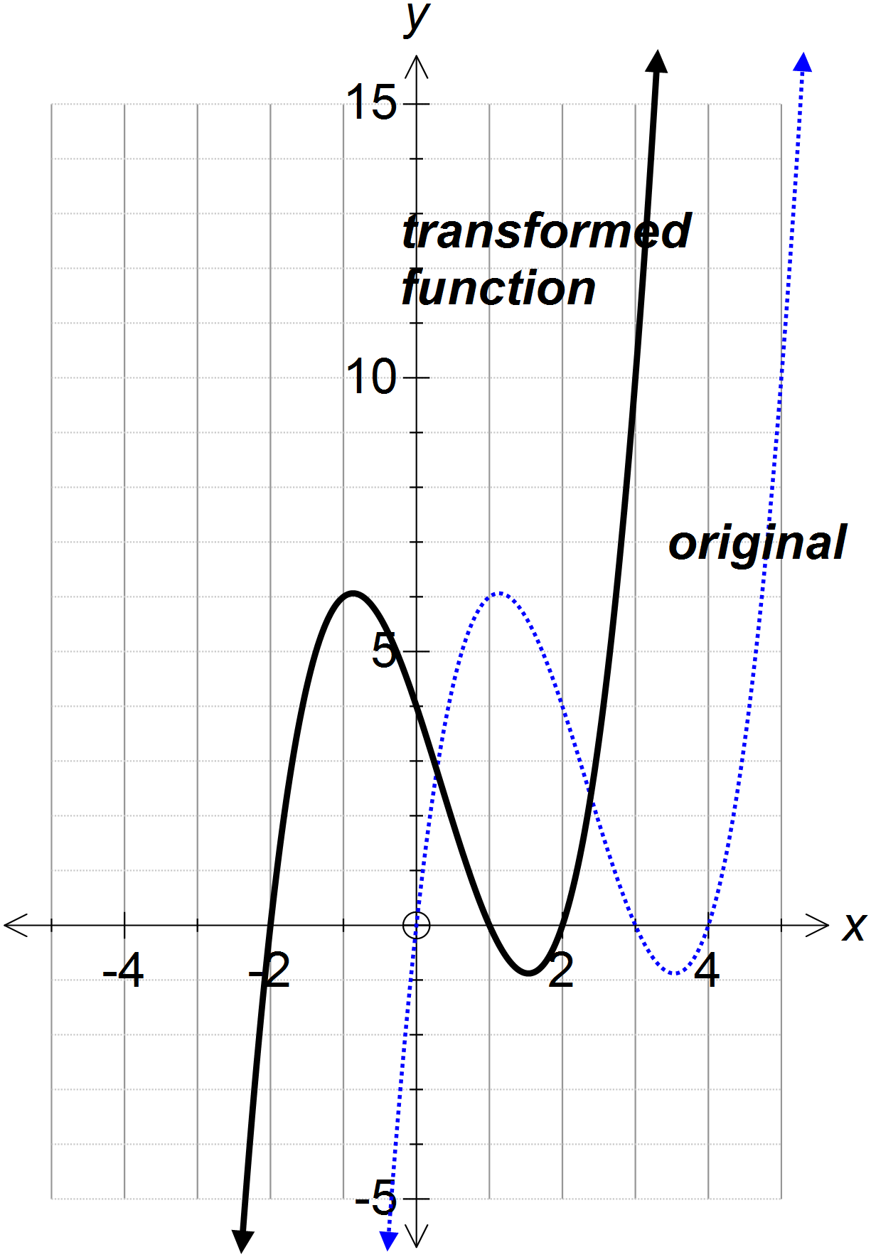

$f(x)→$ ________________________ $f(x)→$ ________________________

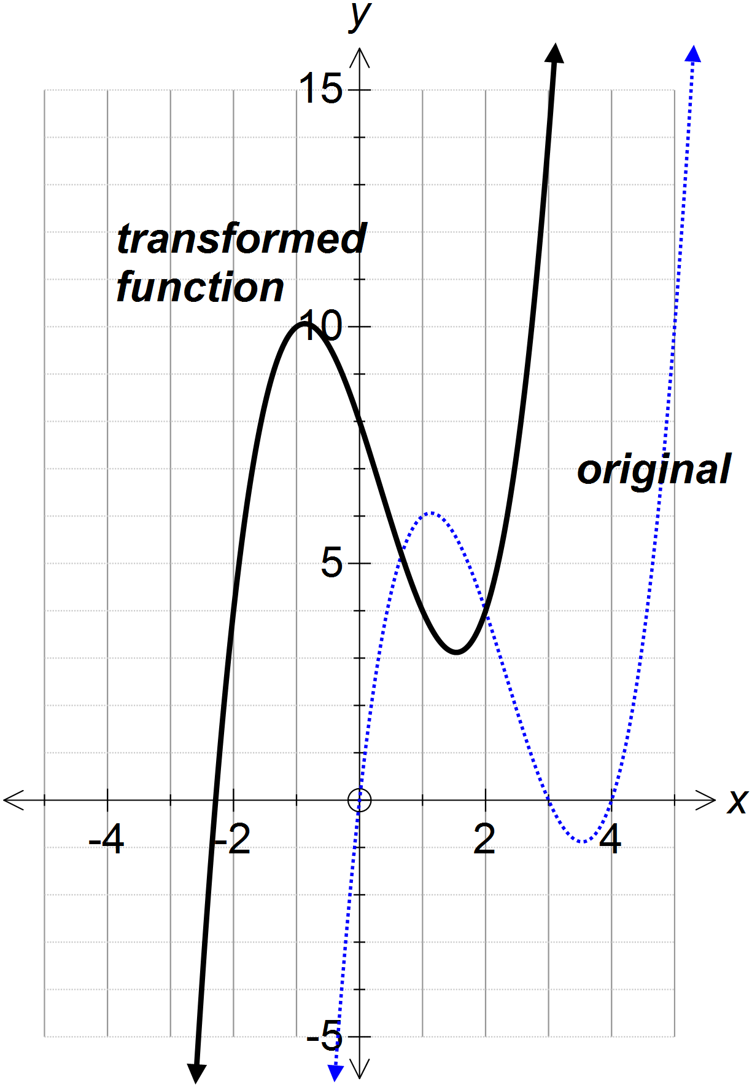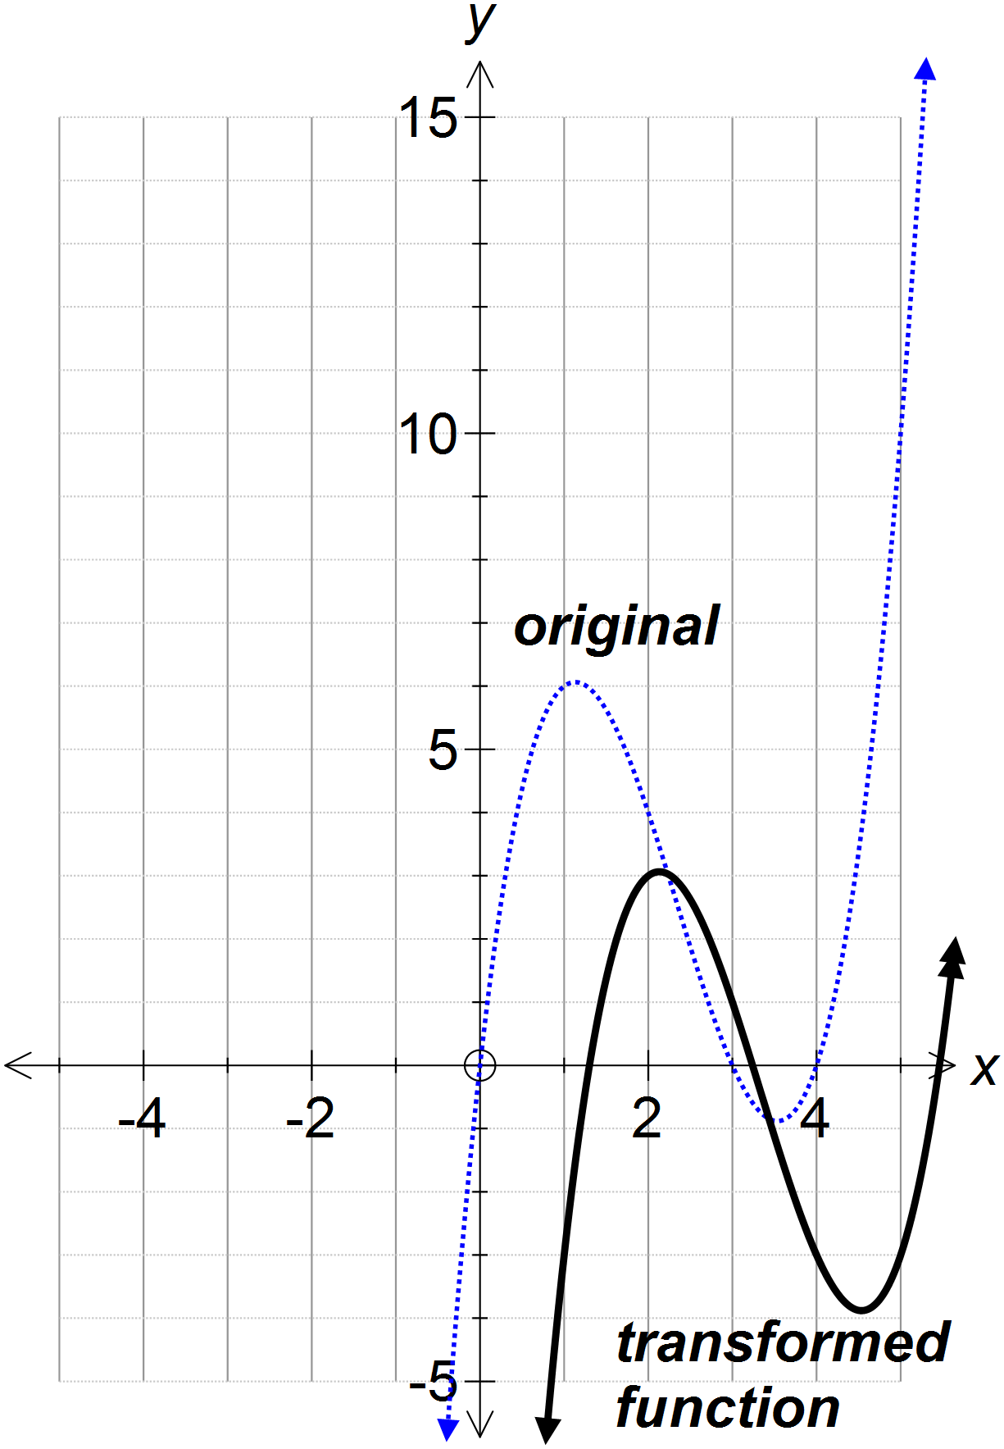

$f(x)→$ ________________________ $f(x)→$ ________________________
PRACTICE PROBLEMS 5
Describe in order the transformations shown by the following functions:

1. $f\left(x\right)→-f\left(x\right)+3$ 2. $f\left(x\right)→2f\left(x\right)-1$

3. $f\left(x\right)→f\left(x-1\right)+4$ 4. $f\left(x\right)→2f\left(x-3\right)$

5. 6.

7. 8.

PRACTICE PROBLEMS 6
Describe in order the transformation that take place from graph 1 to graph 3 in each case:

1.
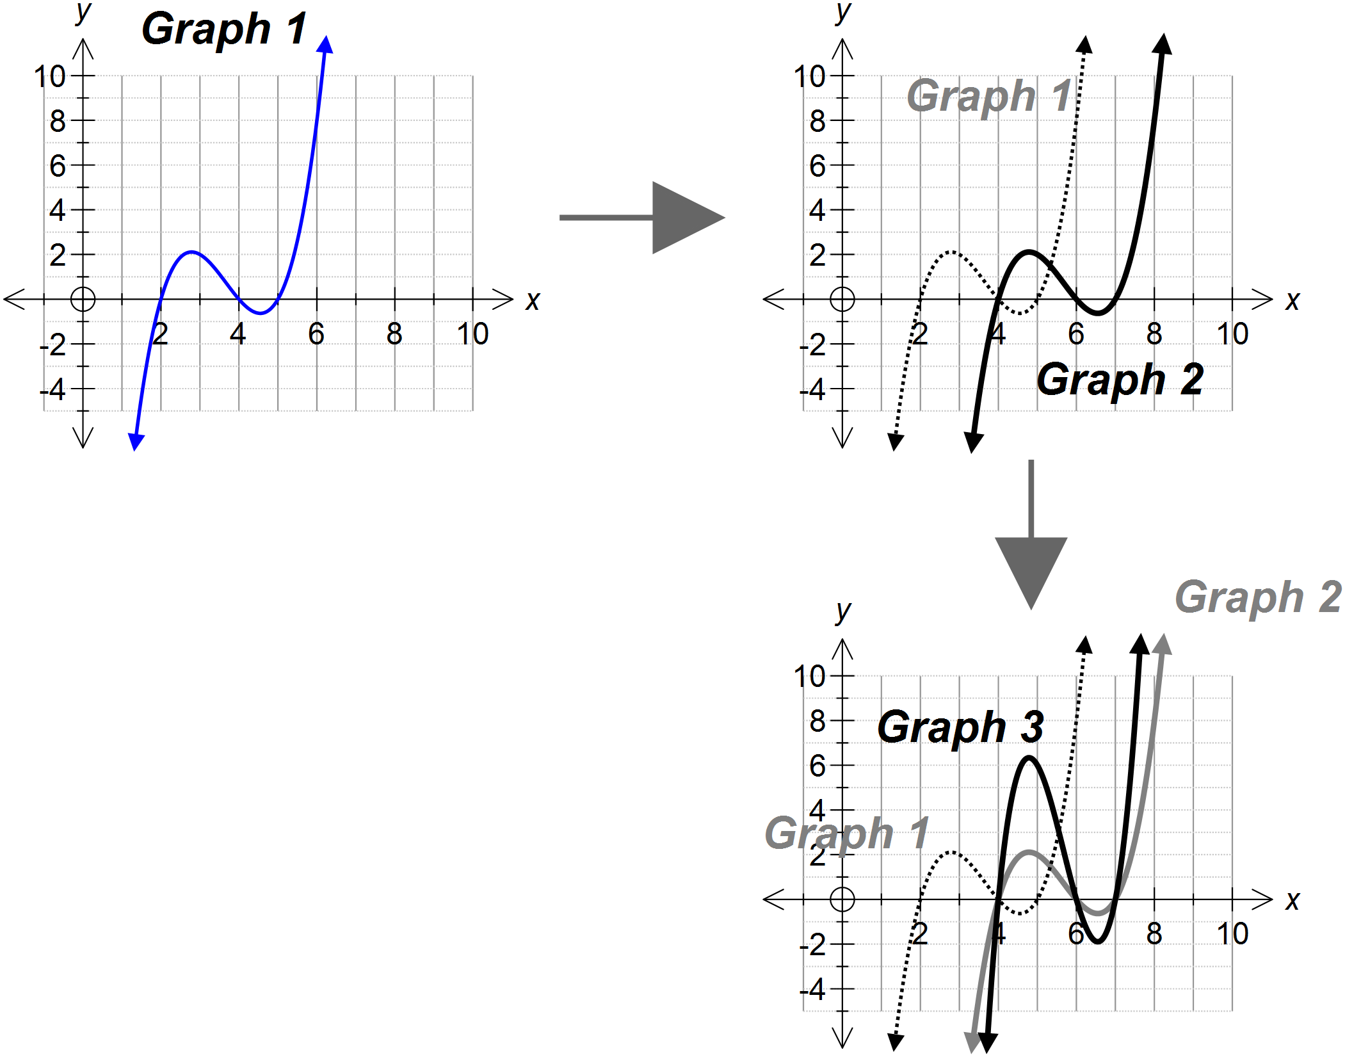

2.

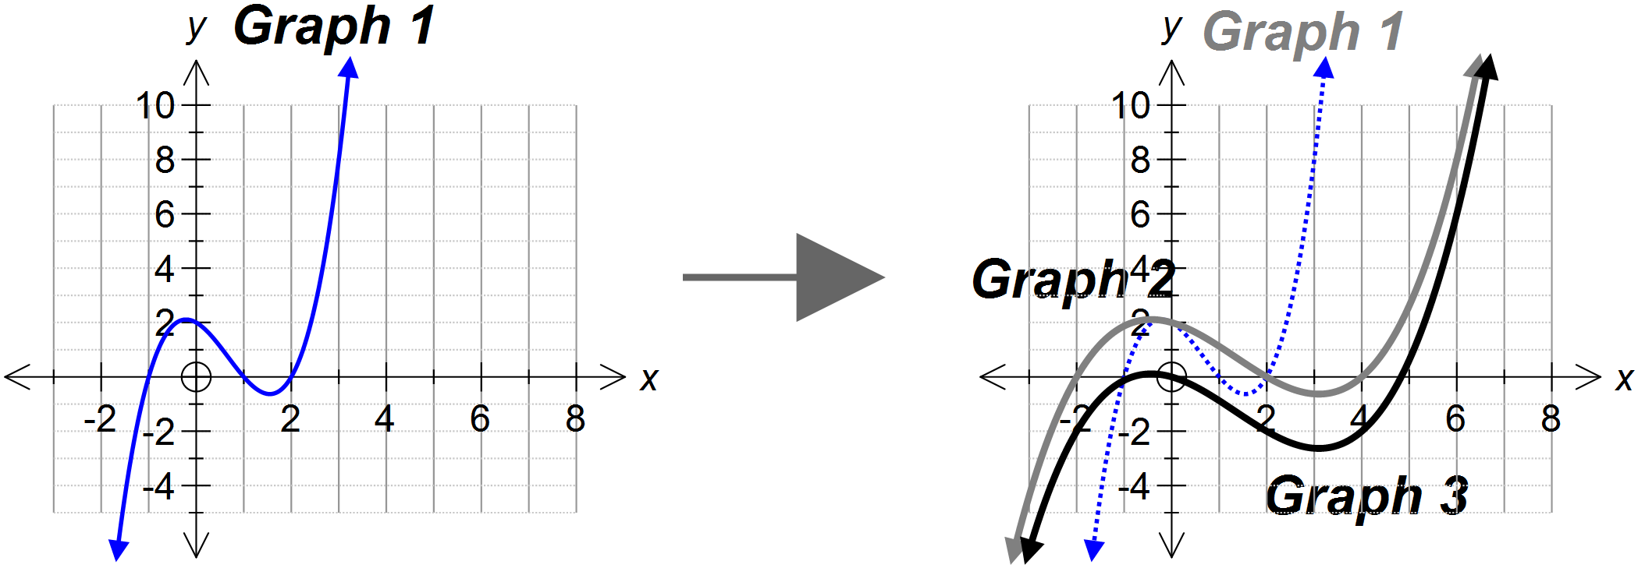

PRACTICE PROBLEMS 7
Describe the transformation(s) that take place to create the second graph from the first:

1.
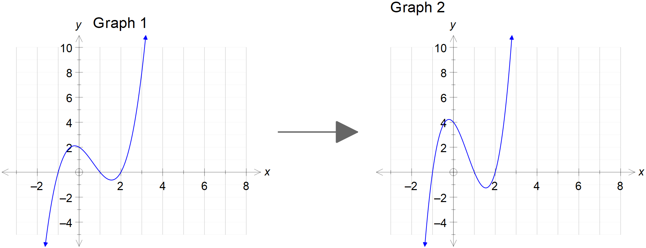

2.
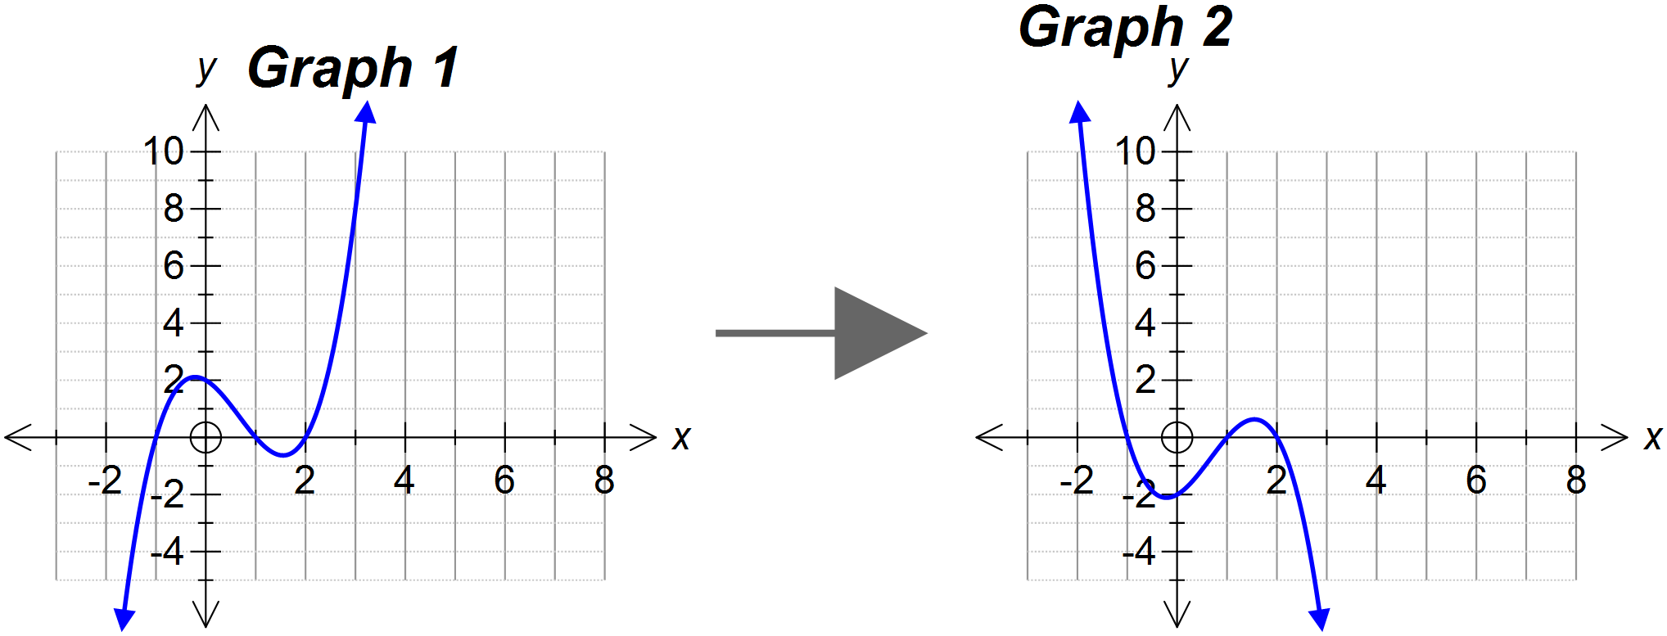

3.
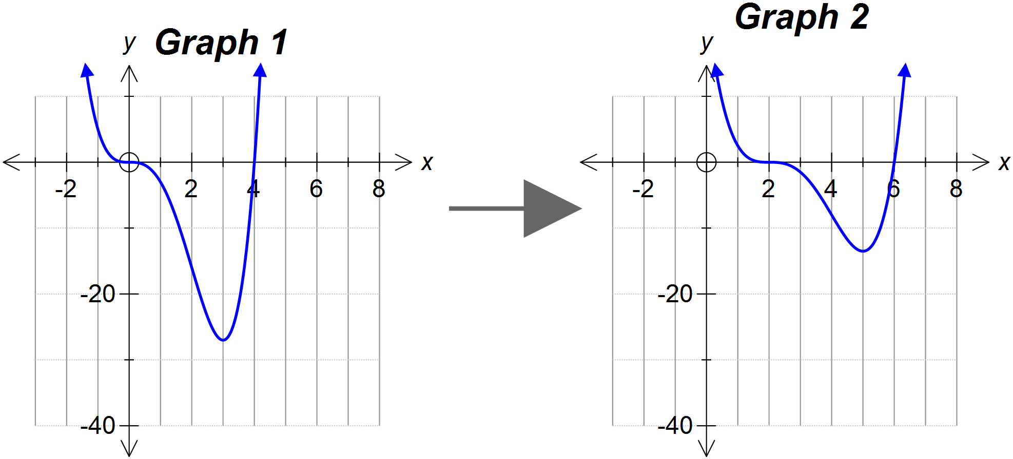

END OF INVESTIGATION

